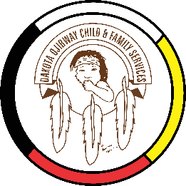
DOCFS EMPLOYMENT OPPORTUNITY

FAMILY WELLNESS WORKER
Roseau River Community Services Office

Dakota Ojibway Child & Family Services requires a Family Wellness Worker for the Roseau River Community Services Office. The position is responsible for providing a wide range of Child & Family Services.

Applicants must meet the following criteria:
- B.S.W., Post-secondary degree in a related field of study and/or Child & Family Services Diploma
- Minimum of two years’ experience in Child & Family Services providing mandated/voluntary services
- Knowledge of the Manitoba Child & Family Services Act
- Demonstrated knowledge of collateral services/community resources and how to access
- Good time management and organizational skills
- Have a valid driver’s license, access to a vehicle and willing to travel
- Excellent work record/history
- Ability to speak Ojibway is a definite asset
- Awareness and respect for the Dakota and Ojibway a definite asset

Salary commensurate with education and experience. All applicants must submit with their application a current Criminal Record Check (with Vulnerable Section Query), Prior Contact Check, and Child Abuse Registry Check. Interested parties should apply in writing including three written references to:

Dakota Ojibway Child & Family Services Inc.
Forest Hills Administration Office
Swan Lake First Nation
Box 310 Carberry, MB R0K 0H0
Attention: Human Resource Coordinator
Phone: 204-834-2323 Fax: 204-834-2306
Email: hr@docfs.org
APPLICATION DEADLINE: Open Until Filled

We thank all who apply, however, only those selected for an interview will be contacted. Preference will be given to Indigenous people and applicants are asked to self-declare in their resume or cover letter.

